
Date of notice issue: Friday 24th November 2023

Public Notice: You are invited to attend the next meeting of the General Purposes Committee, which will be held in the Council Chamber, Whitworth Civic Hall, Market Street, Whitworth on Thursday 30 November 2023 at 7.30pm

AGENDA:

To receive apologies and the reasons for absence.

To receive any Declarations of Interest.
- To consider the minutes of the meeting held on 7th September, and to approve them by signature of the Chairman as a correct record.

Public Question Time.

Planning Applications for consideration and comment:
- 2023/0519 Householder – 9 New Way, Whitworth, OL12 8AN – First floor “build over” extension to existing dwelling.
- To consider changing the start times of Whitworth Town Council council meetings.
- To discuss assisting Stronger Together with room hire for their Christmas events.
- To discuss being involved in Lancashire County Council’s Local Nature Recovery Strategy for Lancashire

To receive reports from delegates and representatives to outside organisations (for information only).

To receive and, if appropriate, adopt the financial statement presented by the Clerk.

To authorise the signing of orders for payment: schedule 8, 2023-2024.

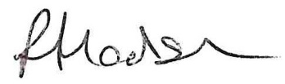
To carry out the Internal Audit.

Rachel Hodson, Clerk to the Council

