Agenda:
- To receive apologies and the reasons for absence.

- To receive any declarations of interest.

- To receive an update from Whitworth’s elected representatives on Rossendale Borough Council on Rossendale Leisure Trust.

The Town Council will consider passing the appropriate resolution under section 100(A)(4) of the Local Government Act 1972 that the press and public be excluded from the meeting during consideration of agenda item 3 since it involves the likely disclosure of exempt information under Part 1 Paragraph 3 of Schedule 12A to the Local Government Act 1972.

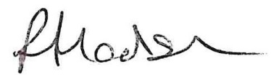
Rachel Hodson, Clerk to the Council

